Assignment (N+) IPv6
Task-1:
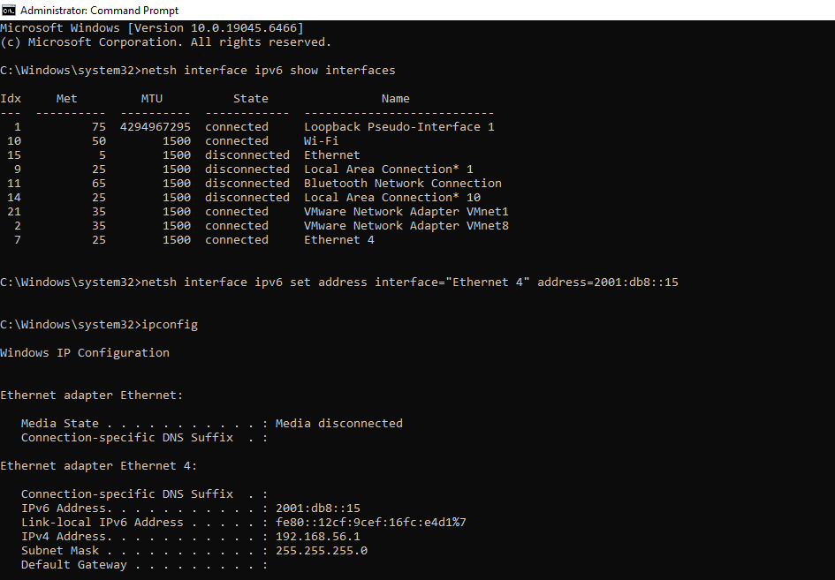

Task-2:Click on this

Task-3:Click on this

Task-4: Click on this

